**Exercise 1: Setting Up Junit**

<!-- Add this to your pom.xml -->

<dependency>

<groupId>junit</groupId>

<artifactId>junit</artifactId>

<version>4.13.2</version>

<scope>test</scope>

</dependency>

Public class MyTestClass {

// Empty for now – will add test methods later

}

**Exercise 3: Assertions in Junit**

Import org.junit.Test;

Import static org.junit.Assert.*;

Public class AssertionsTest {

@Test

Public void testAssertions() {

// Assert equals

assertEquals(5, 2 + 3);

// Assert true

assertTrue(5 > 3);

// Assert false

assertFalse(5 < 3);

// Assert null

assertNull(null);

// Assert not null

assertNotNull(new Object());

}

}

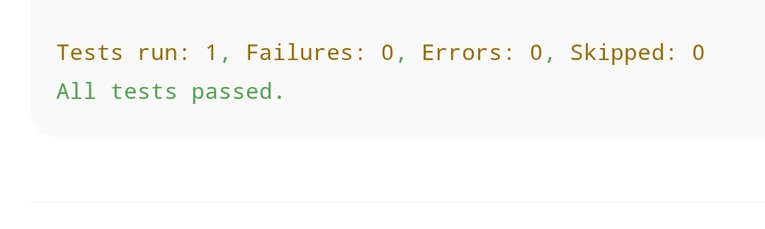

**Exercise 4: AAA Pattern – CalculatorTest Output**

Import org.junit.Before;

Import org.junit.After;

Import org.junit.Test;

Import static org.junit.Assert.*;

Public class CalculatorTest {

Private Calculator calculator;

@Before

Public void setUp() {

Calculator = new Calculator(); // Arrange

}

@After

Public void tearDown() {

Calculator = null;

}

@Test

Public void testAddition() {

Int result = calculator.add(2, 3); // Act

assertEquals(5, result); // Assert

}

}

